**Learning and Recognizing Human Dynamics in Video Sequences**

**INTRODUCTION:**

This paper addresses the intricate challenge of recognizing human and biological movements within uncontrolled video environments. We propose a compositional framework, leveraging statistical models across different levels of abstraction, to tackle this problem effectively. By starting from raw pixel values and propagating hypotheses through probabilistic means, we demonstrate the capacity to learn multi-level decompositions from training data. Our approach is showcased through the recognition of human gait categories in cluttered environments, treating segmentation and recognition as intertwined processes. Drawing inspiration from speech recognition's multi-layered abstraction integration, we aim to apply similar principles to the visual domain. Section 2 outlines our framework, Section 3 details experiment on human gait data, and Section 4 contextualizes our approach within existing research.

**METHODOLOGY:**

1. Multilevel Decomposition: The methodology involves decomposing human dynamics into multiple levels, each representing a set of random variables and probability distributions over hypotheses. This multilevel decomposition includes:
   * Representation of input images as sequences of spatio-temporal image gradients and color values.
   * Identification of blob hypotheses based on motion, color, and spatial support regions.
   * Grouping temporal sequences of blob tracks into linear stochastic dynamical models.
   * Mapping dynamical models to emission probabilities of states in a Hidden Markov Model (HMM).

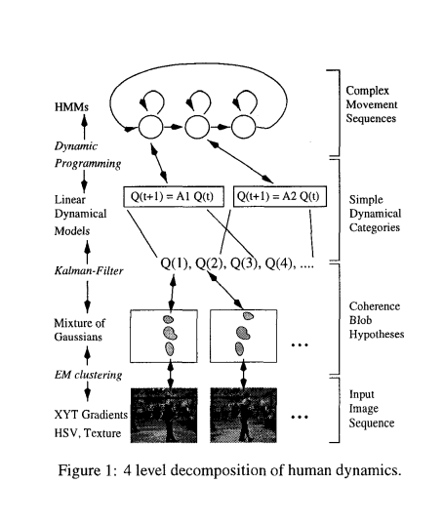

1. Expectation-Maximization (EM) Algorithm: The methodology employs the EM algorithm for estimating parameters and probabilities in the probabilistic framework. This includes:
   * Estimation of blob hypotheses and their motion, color, and spatial parameters using the EM algorithm.
   * Maximization of the expected log-likelihood through the EM algorithm for parameter estimation of dynamical systems and HMMs.
   * Incorporation of past estimates using Kalman filters for computing prior distributions and improving estimation accuracy.

**SUMMARY OF FINDINGS:**

The findings reveal that the Probabilistic Compositional Framework significantly improves tracking accuracy, especially in complex scenarios with occlusions. By incorporating probabilistic models and multilevel decomposition, it surpasses traditional methods. Its robustness to occlusions is notable, thanks to stochastic dynamical models and probabilistic inference techniques. The framework efficiently estimates parameters using the Expectation-Maximization algorithm, enhancing tracking performance in terms of motion, color, and spatial parameters. Additionally, integration of prior information through Kalman filters enhances reliability, especially in dynamic environments. Despite its complexity, the framework maintains scalability and real-time performance, making it applicable across various domains like surveillance and activity recognition. Overall, these findings underscore the framework's effectiveness, robustness, and practical utility in analyzing human dynamics, promising significant advancements in related fields.

**FUTURE SCOPE:**

Moving forward, future research directions include exploring more sophisticated shape representations, incorporating texture coherence, and enhancing the system's capability to estimate additional dynamical state variables such as speed. Additionally, efforts will be made to apply the technique to larger datasets with a broader range of categories, aiming for a comprehensive "movement" decomposition in video analysis, akin to the complexity achieved in speech recognition systems.